**SOCAC** or **RACTSI**   
**ID#**

**Response Surface Metamodel-based Performance Reliability for Reinforced Concrete Beams Strengthened with FRP sheets**

**(Max 70 characters)**

Authors 1, Authors 2,….

(Underline the speaker in Munich)

NOTE: The title, names, text, equations, tables and figures have been altered and pasted from different manuscript for the purpose of format illustration ONLY.

This format can be used as a template to copy and paste your manuscript titles and sections

**Synopsis**: A detailed investigation on the concrete specimens (3.94 in. [100 mm] diameter and 7.87 in. [200 mm] height) (Units of measurement must be in dual units) made with different chemical admixtures was carried out after 10 years of tidal exposure. Chemical admixtures include air-entraining admixture (vinsol), water-reducing admixture (lingosulfonate group), various high-range water-reducing and air-entraining admixtures (naphthalene, melamine, polycarboxyl and amino-sulfonate group) and drying-shrinkage-reducing admixture (glycol ether plus amino alcohol derivatives). The specimens were tested for compressive strength, Young’s modulus of elasticity, carbonation depths, chloride ingress, pore size distribution, electrochemical and physical evaluation of steel bar’s corrosion in concrete, examination of steel-concrete interfaces, and mineralogy of the mortar portions of concrete………….. (MAX 200 WORDS)

**Keywords:** Chemical admixtures; Chloride ingress; Corrosion; Durability; …. (MAX 9 KEYWORD)

## INTRODUCTION

Water-reducing chemical admixtures are used to produce concrete of higher strength, obtain a specified strength at lower water-cementitious ratios (*w/c*), or increase the slump of a given mixture without an increase in water content. Numerous studies on the properties of fresh concrete mixed with different chemical admixtures were carried out to investigate the fresh concrete properties or the concrete properties at an early age of exposure. There were also several international conferences held focusing on the chemical admixtures in the last couple of decades. Detailed studies on the long-term performance of concrete mixed with different chemical admixtures, however, are very scarce in the technical literature. Therefore, studies on the long-term performance of chemical admixtures will be. …………….

## RESEARCH SIGNIFICANCE (MAX 100 WORDS)

Different types of high-range water-reducing and air-entraining chemical admixtures were developed in the last couple of decades. Most of the studies on these admixtures were carried out to judge the properties of fresh concrete, or the properties of concrete at an early age. Studies on the long-term performance of concrete made with different water-reducing admixtures are very scarce in the technical literatures. The authors believe that this detail study dealing with the long-term performance of different chemical admixtures is carried out for the first time and will be very useful to concrete technology.

Experimental Investigation (or Experimental Procedure)

Cylinder specimens with and without steel reinforcements (3.94 in. [100 mm] diameter and 7.87 in. [200 mm] height) of 19 separate cases were investigated. The variables include cement types (ordinary portland cement, blended cement replaced by slag powder of 4080 and 7900 cm2/g), air-entraining (vinsol) chemical admixture, water-reducing (lignosulfonate type) chemical admixture, high-range water-reducing and air-entraining (naphthalene, melamine, polycarboxyl, and amion-sulfonate types) chemical admixture, drying-shrinkage-reducing chemical admixture (glycol ether plus amino alcohol derivatives), slag content, and w/c. The specimens were exposed to a tidal pool for 10 years using seawater. In each case, four specimens without reinforcement and three specimens with reinforcement were investigated……………

Materials

Ordinary portland cement (OPC) and blended cements by replacing a portion of the cement with slag powder were used. Two kinds of slag powders were used with Blaine fineness of about 7900 cm2/g (Slag 1) and 4080 cm2/g (Slag 2). The physical properties and chemical analysis of the cement and slag powders are listed in Table 1. River sand and crushed granite coarse aggregates were used. The specific gravity, water absorption, and fineness modulus of sand (passing through 0.20 in. [5 mm] sieve opening size) are 2.63, 1.63 and 2.73, respectively….

Table 1–Physical and chemical compositions of cement and slag

|  |  |  |  |
| --- | --- | --- | --- |
|  | OPC | Slag 1 | Slag 2 |
| **Specific gravity** | 3.16 | 2.90 | 2.90 |
| Blaine fineness, cm2/g | 3190 | 7900 | 4080 |
| Loss of ignition, % | 0.7 | **–** | **–** |
| SiO2, % | 21.3 | 32.7 | 33.2 |
| Al2O3, % | 5.3 | 13.8 | 14.1 |
| CaO, % | 64.4 | 42.4 | 42.3 |
| MgO, % | 2.2 | 5.9 | 5.9 |
| SO3, % | 1.9 | 2.0 | 2.0 |
| Na2O, % | 0.28 | **–** | **–** |
| K2O, % | 0.6 | **–** | **–** |
| TiO2, % | 0.37 | **–** | **–** |
| MnO, % | 0.1 | **–** | **–** |
| Fe2O3, % | 2.6 | 0.2 | 0.2 |

**– =** not measured items.

Specimens

Plain and reinforced cylinder specimens of diameter 3.94 in. (100 mm) and length 7.87 in. (200 mm) were investigated. The test setup is shown in Fig. 1. Round steel bars of diameter 0.35 in. (9 mm) and length 5.51 in. (140 mm) were embedded at cover depths of 0.79 and 1.79 in. (20 and 45.5 mm).

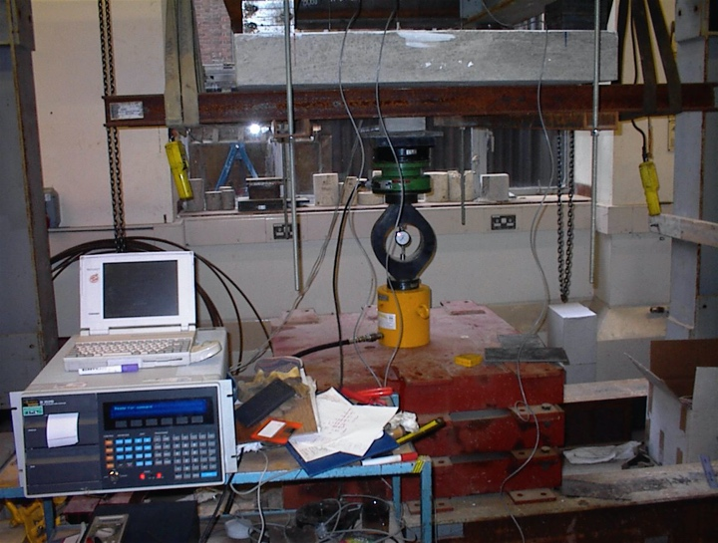

**Fig. 1–An overview of a specimen in position ready for testing.**

Analytical investigation (or analytical procedure)

The maximum prestress force in the CFRP tendons should be limited to 65% of the specified tensile strength of tendons. It is suggested by Hognested [1] that an appropriate value of the elastic modulus of a concrete member, subjected to bending and axial load, can be obtained from (Equations should be numbered):

 (1)

where  is the cylinder strength of concrete…………..

EXPERIMENTAL RESULTS AND DISCUSSION

Compressive strength and Young’s modulus of elasticity

Compressive strengths and Young’s modulus of elasticity of concrete at 28 days and after 10 years of exposure in the tidal environment are shown in ………..

FURTHER RESEARCH (If applicable)

It is desirable to test specimens at the age of 20 or more years of exposure, and efforts should be made to find out the possible ways to increase the chloride threshold value related to corrosion of steel bars in concrete. The results of such studies would directly benefit the construction industry……………….

CONCLUSIONS (or Summary and conclusions)

Based on the results of this experimental investigation under tidal environment, the following conclusions are drawn:

1. Naphthalene group of high-range water-reducing and air-entraining chemical admixture shows the best performance against the strength development and chloride ion ingress prevention in concrete; and
2. Polycarboxyl group of chemical admixture shows the least performance among the chemical admixtures investigated here against long-term strength development as well as chloride ingress prevention in concrete…………………

ACKNOWLEDGMENTS (If applicable)

The authors wish to express their gratitude and sincere appreciation to………for financing this research work and also several on-going research projects related to the durability of concrete structures………………

NOTATION: (IF APPLICABLE, especially if the list of symbols is long)

α = radius of slab

β = diameter/side length of loaded area

γ = parameter related to ratio of compressive to tensile strengths of concrete

REFERENCES (Numbered)

[1] Nagataki, S., “State of the Art Report on Air-Entraining High Range Water-Reducing Admixture, *Concrete Journal of JCI*, Japan, V. 28, No. 6, 1990, pp. 5-15.

[2] Hattori, K., “Experiences with Mighty Superplasticizer in Japan,” *Superplasticizers in Concrete*, SP-62, V. M. Malhotra, ed., American Concrete Institute, Farmington Hills, Mich., 1979, pp. 37-66.

[3] Lin, T. Y., and Burns, N. H., “Design of Prestressed Concrete Structures,” 3rd Edition, John Wiley & Sons Publisher, New York, 1981, 368 pp.

[4] Naaman, A. E., and Alkhairi, F. M., “Stress at Ultimate in Unbonded Post-tensioning Tendons: Part 2- Proposed Methodology,” *ACI Structural Journal*, V. 88, No. 6, Nov.-Dec. 1991, pp. 683-692.

Appendix (IF APPLICABLE)

The following paragraph reports ….

Biography

ACI member **Author 1** …. (MAX 75 words for each author)